Mailing Address  House No. # 48/2,  Lane # Baishtake,  Sector# 13, Mirpur,  Dhaka-1216.  Phone: +88 01981480120  E-mail: Hasibhosen7612@gmail.com | 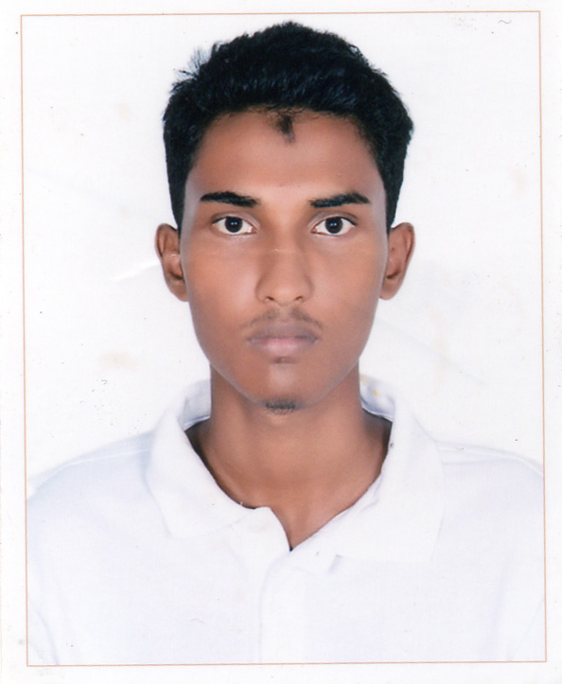

Mohammad Hasibul Hossain
Career Objective | To be associate with a progressive organization which can provide me with a dynamic work sphere to extract me inherit skills as a professional, use and develop my aptitude to further the organization’s objectives and also attain my career targets in the progress.
Education | Bachelor of science (B.S.C)  - Computer Science  - Studying  - Result: CGPA 3.43 out of 4.00  - Bangladesh University of Business and Technology
Higher Secondary Certificate (H.S.C)
- Science
- Passing Year: 2014
- Result: GPA: 5.00 out of 5.00
- Shaheed Police Smrity College
Secondary School Certificate (S.S.C)
- Science
- Passing Year: 2012
- Result: GPA: 4.96 out of 5.00
- Shaheed Police Smrity College
Key Qualities | - Strong appetite for Leadership an honest life with dignity.  - Capable to build up relation with any status of People.  - Flexible, Self-motivated and able to work under pressure.  - Proficient academic background and analytical ability.
Languages | - English: Have a good command in both Speaking and Writing  - Bengali: Mother Tongue  - Hindi: Capable of Understand and Speaking
Computer Skill | - Expert in Microsoft word, Power-Point, Excel & Outlook.  - Expert in handling E-mail.  - Experienced in windows and windows based application.  - Experienced in language (C, C++, C#, PHP, MySql etc.)  - Competitive Programming.
Personal Details | Full Name: Mohammad Hasibul Hossain  Father’s name: MD. Monowar Hossain  Mother’s name: Hasina Akhter  Date of Birth: February 08, 1996  Nationality: Bangladeshi  Marital Status: Single  Religion: Islam  Gender: Male  Cell No: +88 01981480120  Permanent Address: 48/2, Baishtake, Mirpur 13, Dhaka.
References | Samsuddin Ahmed  Chairman (Acting)  Dept. of CSE  Bangladesh University of Business and Technology  Cell: 01911436977  E-mail: sam@bubt.edu.bd | MR. MD. SAIFUR RAHMAN  Assistant Professor  Department of CSE  Bangladesh University of Business and Technology  Cell: 01687268343  E-mail: saifurs@bubt.edu.bd


Mohammad Hasibul Hossain

